**Лабораторная работа**

**Скриншот:**

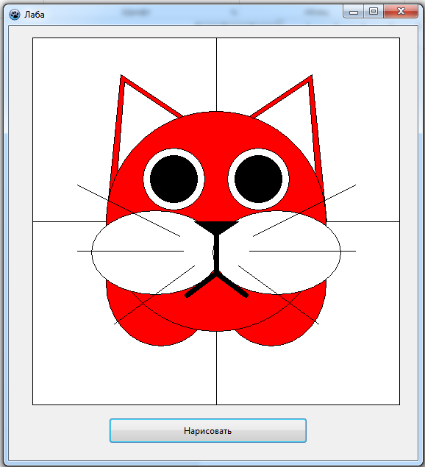

**Код процедуры:**

{ TForm1 }

procedure TForm1.Button1Click(Sender: TObject);

begin

begin

with Paintbox1.Canvas do

begin

Brush.Color := clWhite;

Rectangle(0,0,500,500);

Line(0,250,500,250);

Line(250,0,250,500);

Brush.Color := clRed;

Polygon([Point(100,250),Point(120,50),Point(210,110)]);

Polygon([Point(400,250),Point(380,50),Point(290,110)]);

Brush.Color := clWhite;

Polygon([Point(110,250),Point(125,60),Point(200,110)]);

Polygon([Point(390,250),Point(375,60),Point(300,110)]);

Brush.Color := clRed;

Ellipse(100,420,250,250);

Ellipse(400,420,250,250);

Ellipse(100,100,400,400);

Brush.Color := clWhite;

Ellipse(80,350,255,235);

Ellipse(420,350,245,235);

Brush.Color := clBlack;

Polygon([Point(220,250),Point(280,250),Point(250,270)]);

Brush.Color := clWhite;

Ellipse(150,150,235,235);

Ellipse(265,150,350,235);

Brush.Color := clBlack;

Ellipse(160,160,225,225);

Ellipse(275,160,340,225);

Pen.Width:=7;

Line(250,255,250,320);

Line(250,320,210,350);

Line(250,320,290,350);

Pen.Width:=1;

Line(200,270,60,200);

Line(205,290,60,290);

Line(220,310,110,390);

Line(300,270,440,200);

Line(295,290,440,290);

Line(280,310,390,390);

end;

end;

end;